Create RAID storage in Exatron Server
step :- 1
Firstly reboot your server and press “ctrl+R”
step:-2
after press ctrl+R this screen show
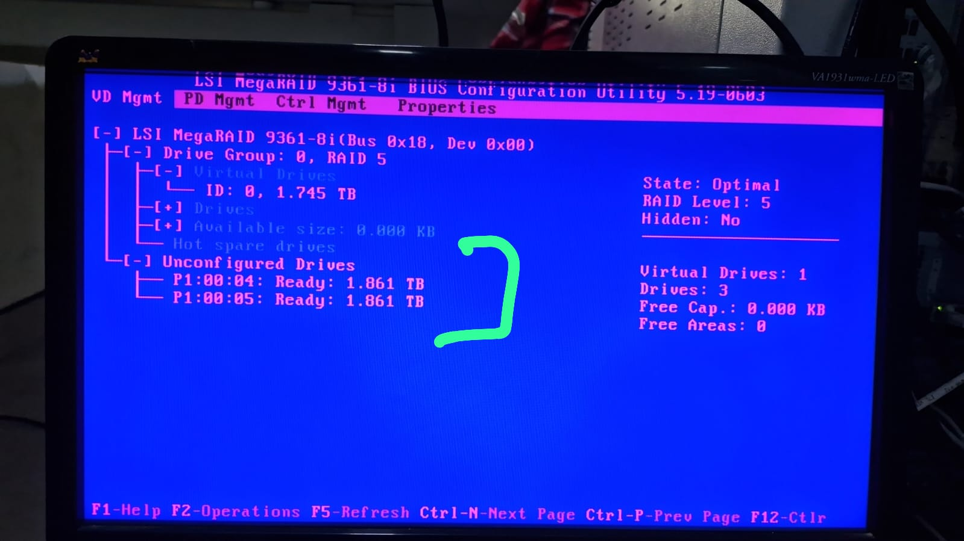
step:-3
Now, Select VD Mgmt select this “LSI MegaRAID 9361” press ENTER
step:-4
Now, you can create RAID 0 selct all unused disk and give the name of RAID .
step:-5
After create RAID you can go to PD Mgmt and check all disk show online or not. This screen show.
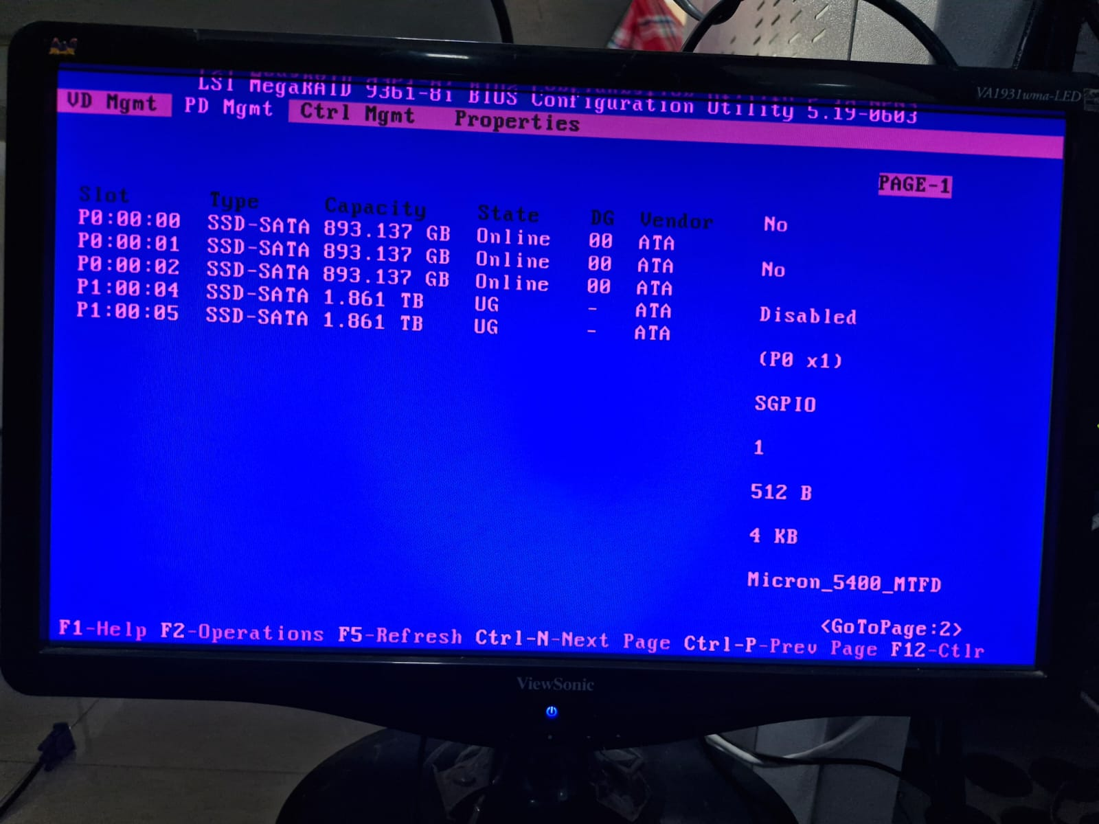
step:-6
IF disk is proper online show now you can reboot your server and check in CLI mode.

